Day 1 Titanic: Informative Writing

Age Level: 5th Grade
Subject(s) Area: Language Arts
Materials Needed: Large white poster, coloring utensils, and a laptop

Standards:
5.R1.9 “Integrate information from several texts on the same topic in order to write or speak about the subject knowledgeably.”

5.W.2 “Write informative/explanatory texts to examine a topic and convey ideas and information clearly.”

Objectives:
Students will design an informative poster using key details from several texts to express their level of knowledge on the given content at a 95% accuracy level.
Learning Activities:
Required Vocabulary:
- Informative - providing useful or interesting information.

Opening Element:
I found a quote from a young girl named Eva Hart, whom was a survivor from the Titanic. (Show on PowerPoint) Eva said: "And it wasn't until we were in the lifeboat and rowing away, it wasn't until then I realized that ship's going to sink. It hits me there." - Eva Hart, Titanic Survivor
From this quote, I think I would have felt the same way. I would react and help those around me without realizing what was actually occurring.
By raising your hand, have any of you found a quote that you really liked in the book that you read? (Students respond)

Reflective Question:
By raising your hand, who can tell me something interesting or something that struck out to you when you read the book “I Survived the Sinking of the Titanic, 1912?” (Students share)
Instructional Methods:
1. Today, you will use the information you have gathered from computer lab and the book you have read and create an informative poster. By raising your hand, who can tell me what the term informative means? (Students share)
Informative means providing useful or interesting information.
2. The author informed you about his or her survival. There were facts within the book that you probably never knew about until now. The author kept you engaged throughout the book by describing what he or she went through and how he or she survived.
3. You will be creating an informative poster of the Titanic. You will include fun facts, the history of the Titanic, and something you want others to know about that you found to be interesting.
4. Please take out the “Informative Titanic Poster Guidelines.” (See appendix A) On your poster, you will include the following content area: History of the Titanic, 3 or more Fun Facts, Disaster Strikes, a drawing of the Titanic, and a Timeline. Do not worry about the timeline today. We will be doing this together as a class later this week. Give me a thumbs-up so I can see everyone has the Informative Titanic Poster Guidelines paper out.
5. Today, I just want you to have an idea of how you want your poster to look. Also, start thinking of what you will put in each content area. You should already have an idea of what you will include within each content area so please write that down on a separate piece of paper.
6. What I want you to do is draw a sketch of where you will put everything on your poster. For example, I might put my drawing of the Titanic at the bottom corner of the poster or I might put it right in the middle (model by pointing to a blank poster).
Guided Practice Strategies:
1. I will show you an example of how I would go about doing the poster. Show an example of the poster that I created (See appendix B). In my poster, I knew I had a lot of information under the history content. Because I had a lot of information, I could either take some of it out, but I think it is very important and will inform my reader about the Titanic. I decided to put this on the left side running down almost toward the end.
2. Next, I thought of having my drawing of the Titanic in the middle of the poster so that I could surround fun facts around the drawing. I also thought it would be clever to have the disaster strikes content on the right side of my poster since I already have the history on the left. This gives me room for my timeline to be running on the bottom of the poster. Here are some pictures of the titanic. Start thinking what picture of the titanic you will draw. (Hand out appendix D)
3. You can organize it however you would like. Maybe you want to have your timeline going across diagonally with your titanic on the bottom right corner. It is up to you on how you would like to organize your information so today we will just figure out where you want that information to go. Also, start thinking of what you want your title to be on your poster. I titled mine as Sinking of the Titanic. Maybe you just want to have yours as Titanic or based off your book I Survived the Sinking of the Titanic, 1912.
4. Allow time for students to figure out the layout of their poster.
Wrap-Up: Tomorrow, what do you think you will be doing with your project? (Students respond) Tomorrow, you will be doing textboxes on the computers and then you will be printing off the textboxes and gluing it on your poster. I will also hand out the poster for you to start your project and drawings.

Assessment:
Formative:
- Formal - Students will complete their poster by including the listed content area in appendix A and hand in.
- Informal – Students will give a thumbs up or down if they do or do not understand the information when the teacher is explaining the content area they must use within their poster.
Summative:
- At the end of the project, students will present their poster about what research they have included within their poster.
Reflection:
I thought this lesson went very well. What I think I could have done differently would be to be more enthusiastic right away when introducing the poster. I think this would have allowed them to be excited about creating a magazine layout poster. I also think I should have fostered questions to help guide their thinking on how they want their poster to look.

Appendix A
Informative Titanic Poster Guidelines

Content Area:

1. History of the Titanic
- Who designed and built the ship?
- How was it built?
- What was the size, weight, length, etc. of the ship?
- How many passengers could the ship hold?
- How much did the Titanic cost to be built?

2. At least 3 Fun Facts
Examples:
- How many passengers were on the Titanic?
- How many passengers survived?
- Who was the last remaining survivor?

3. Disaster Strikes
- What time did it occur?
- What side of the ship did it hit?
- How long did it take for the ship to sink?

4. Drawing of the Titanic
- Include different colors

5. Timeline of the Titanic
- Timeline must include from when the ship hit the iceberg to the ship sinking
- There must be 6 main points on the timeline

Appendix B
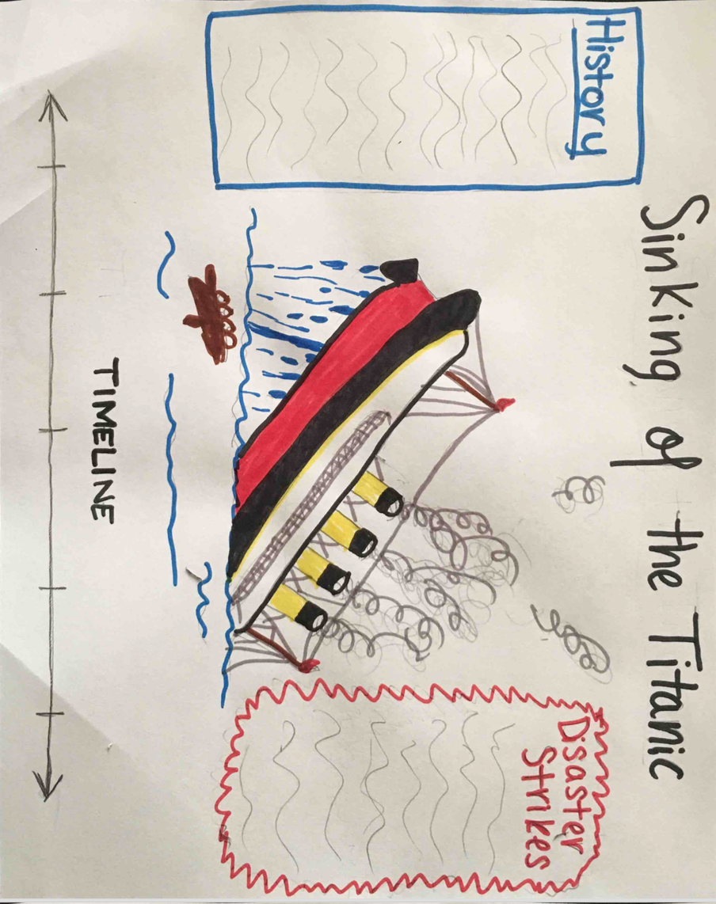

Appendix C
Student Example

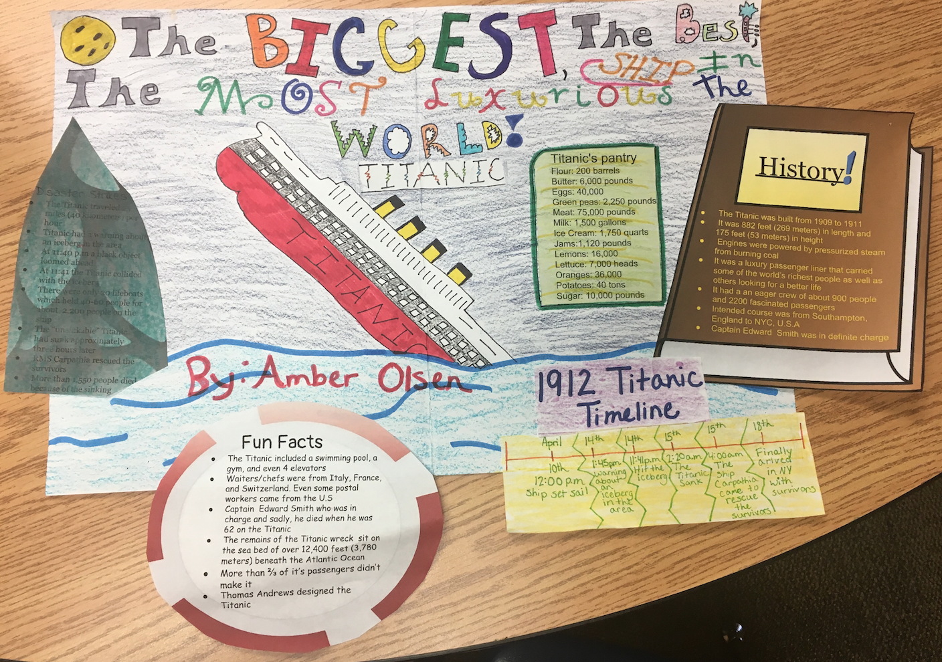

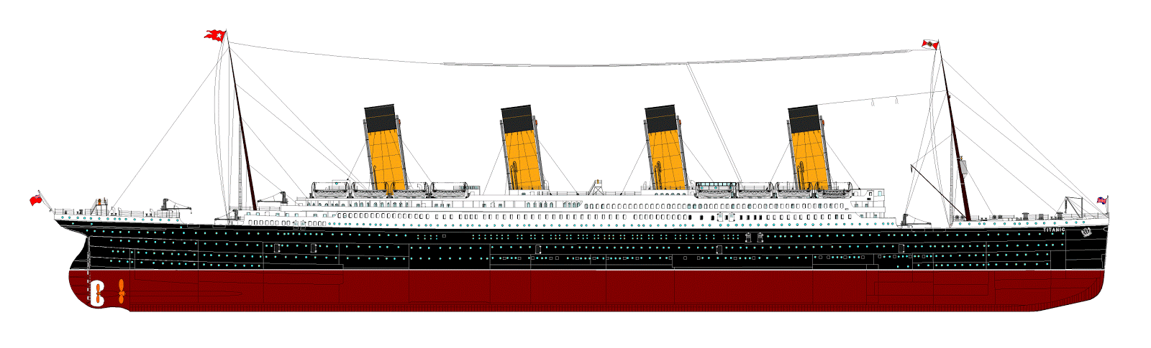
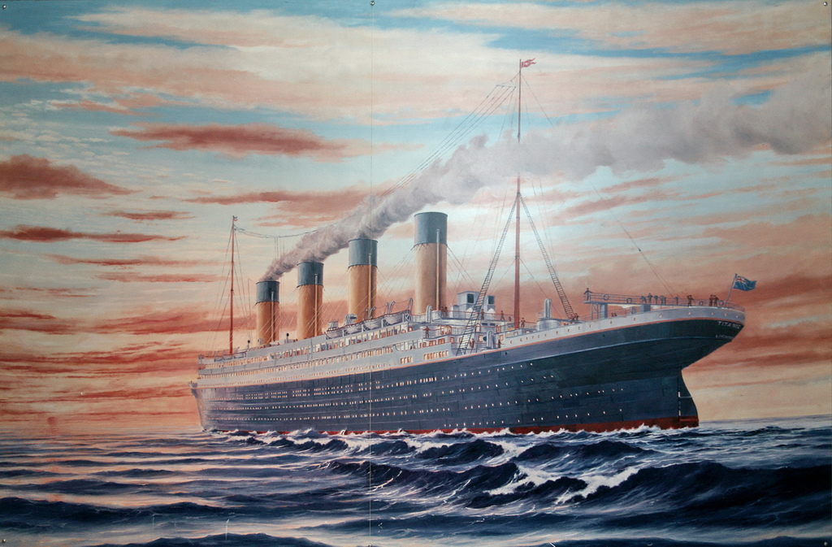
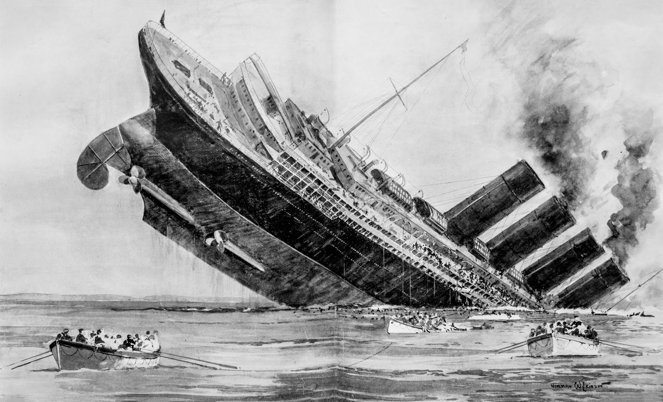
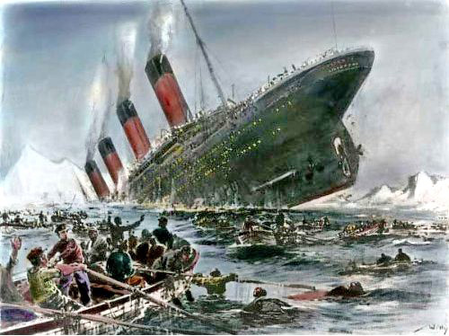
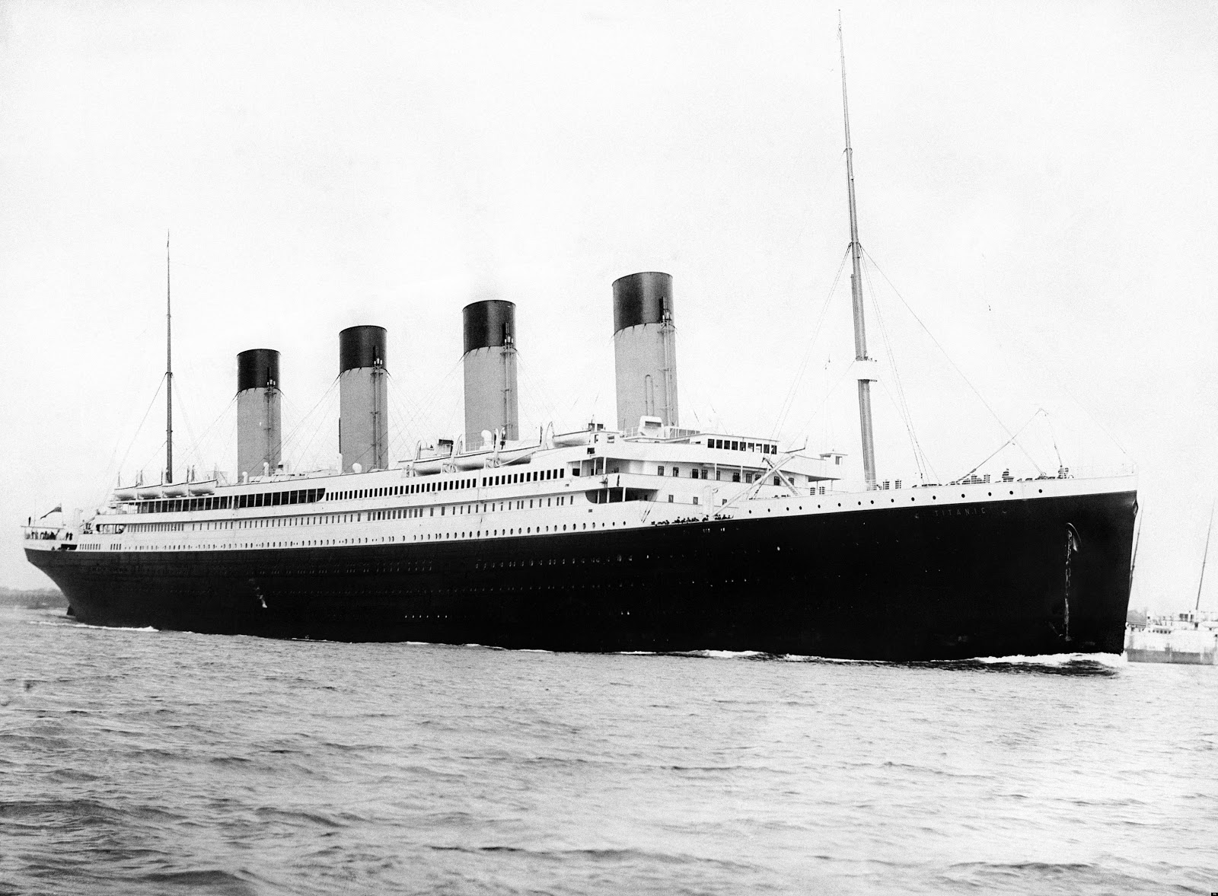
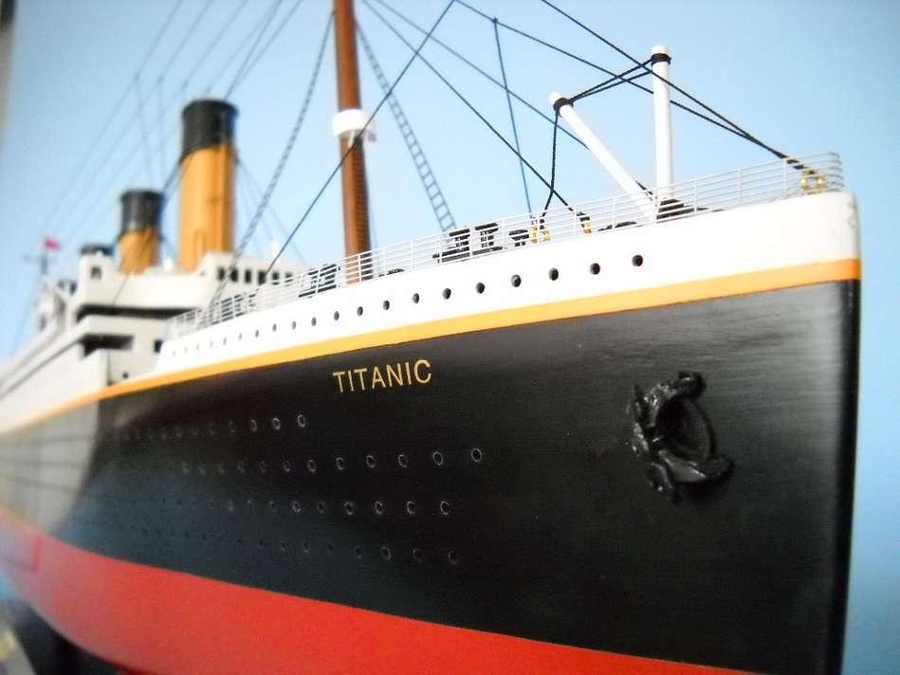
Appendix D
Pictures of the Titanic to guide your drawing

