Grade: 1st |  |  | Subject: Social Studies
Materials: Worksheets (See Appendixes) |  |  | Technology Needed: Active Board
Instructional Strategies:  - Direct instruction  - Guided practice  - Socratic Seminar  - Learning Centers  - Lecture  - Technology integration  - Other (list) |  | - Peer teaching/collaboration/  cooperative learning  - Visuals/Graphic organizers  - PBL  - Discussion/Debate  - Modeling | Guided Practices and Concrete Application:
 |  |  | - Large group activity  - Independent activity  - Pairing/collaboration  - Simulations/Scenarios  - Other (list)  Explain: | - Hands-on  - Technology integration  - Imitation/Repeat/Mimic
Standard(s)  1.2.1 “Compare past and present family life (e.g., housing, transportation, technology) over time.” |  |  | Differentiation  Below Proficiency: Unable to explain more than 1 items from the past compared to the present.  Above Proficiency: Able to explain more than 3 items from the past and how are they are different and similar today.  Approaching/Emerging Proficiency: Able to name 3 items from the past and is able to explain how it is similar and different today.  Modalities/Learning Preferences: Physical, verbal, logical
Objective(s)
- The learner will name 3 different items from the past and explain how they are different and similar today.

Bloom’s Taxonomy Cognitive Level: Understand
Classroom Management- (grouping(s), movement/transitions, etc.)  - Students will move around quietly with their group to look at the artifacts.  - Use “5,4,3,2,1” if students need to quiet down  - Use “Macaroni and Cheese” if needed for students to stop moving |  |  | Behavior Expectations- (systems, strategies, procedures specific to the lesson, rules and expectations, etc.)  - When students are in whole group, they will be sitting criss-cross on the rug.  - Students are expected to move around quietly and safely when looking at the different artifacts located around the room.
Minutes | Procedures
10 | Set-up/Prep:  - Have the document “SS Lesson - School Desks” up and ready to go on the Active Board (See Appendix B)  - Print off a copy of “School Items – Artifacts.” Cut and tape the school artifacts on the wall around the room. (See Appendix A)  - Print off copies of “Artifact hunt” document for every student. (See Appendix C)  - Print off copies of “Past or Present” worksheet (See Appendix D)  - Print off copies of the “School Long Ago and School Today” worksheet for every student each with a number either 1-7. Tape beside the picture of the school artifact on the wall around the room. (See Appendix E)
10 | Engage: (opening activity/ anticipatory Set – access prior learning / stimulate interest /generate questions, etc.)  - Students will be sitting criss-cross on the carpet rug.  - Today, we are going to learn about school in the past versus school today.  - As you can see on the board, there are different types of desks. Some look like they are older and some look like they are newer. I am going to choose a popsicle stick and have that student come up to the board and write a number one by the picture of the desk that they think is the oldest. Then I will draw another Popsicle stick and have that person come up and write a number two by the desk they think is the 2nd oldest. This will continue until all 6 desks have a number by them.  - Draw Popsicle sticks and have the students write the number by the desks.  - Turn and talk to your neighbor, why did you think that these 2 were the oldest (point to number 1 and number 2 that the students wrote their numbers by). (Answers vary)  - Turn and talk to your neighbor, why did you think that these 2 were the newest (point to numbers 5 and 6 that the students wrote their number by). (Answers vary).  - Now, lets look at the correct order of desks from oldest to newest. (Scroll down 2 pages and the correct order will be on the same document.
5 | Explain: (concepts, procedures, vocabulary, etc.)  - What do you think is different from school long ago compared to today? (Answers vary, may include transportation, desks, technology, etc.)  - Make 2 charts on the board, one labeled past and the other present. Write the students’ ideas on the board.  - Today, we are going to learn about how school is different from the past to the present. We will learn how it changed over time. What does the term “past” mean? (Answers vary) Past means that it occurred a long time ago or yesterday. What does the term “present” mean? (Answers vary). Present means that it is happening now or today. We are living in the present.
30 | Explore: (independent, concreate practice/application with relevant learning task -connections from content to real-life experiences, reflective questions- probing or clarifying questions)  - I want you to stay where you are but just look around the room and see the numbers with a picture by it that is posted around the room. Get the students attention if needed by saying “1,2,3, eyes on me.” I am going to put you into groups and you are going to use this paper (hold up Artifact Hunt document) to write down what you think each artifact is and was used for. For example, if I went to artifact 3 and I saw that it looked like a very old tractor, I would put “Tractor” on the line by number 3 since I am at the artifact number 3 station. Then I would write what the tractor was used for on the lines beside it and how it is different from today’s tractors.  - Once you are done and have finished writing what the object was used for and how it is different from today, you can move on to a different artifact station if there is no other group at the station. Once your group is finished, I want you to sit in your desk and you will have a short worksheet to fill out. Explain directions on the “Past or Present” Worksheet.  - Ask the students “What are you going to do when you are done?” (They should all say at once that they are going to sit back down at their desks and fill out the worksheet”  - Give me a thumbs up or down if you understand what you are doing. Thumbs up means you understand, and thumbs down means I need to explain it again. Explain the information if needed.  - Divide the students into groups by using popsicle sticks.  - Have the students grab the Artifact hunt document  - Allow time for students to complete the activity.  - Once all of the students are back in their desks, get the students attention and ask for students to share what they thought each artifact was and what it was used for. Allow time for students to share.  - Explain each artifact and what it was used for. (See appendix F)
10 | Review (wrap up and transition to next activity):  - Now, I want you to finish your worksheet that was placed at your desk and I want you to complete another worksheet. This worksheet is from what you learned from the artifacts. Now that I have explained what each artifact is, think of what is used today in place of that item. For example, instead of lanterns, we use what in classrooms? (Answers vary). So, on the left you could put lanterns and on the right side you can put (answer).  - Thumbs up or down if you know what to do.  - Allow time for students to complete worksheet.  - Thank you 1st graders for being active listeners. Now, Mrs. Nehls is going to lead you into the next activity before it is time to go outside for recess. .
Formative Assessment: (linked to objectives)  Progress monitoring throughout lesson- clarifying questions, check-in strategies, etc.  Give me a thumbs up or down if you understand what to do.  Consideration for Back-up Plan:  If the computer does not work, have a copy of the desks and allow students to tape the pictures on the board from past to present. |  |  | Summative Assessment (linked back to objectives)  End of lesson:  Students will be able to write down 3 different items from the past that and explain how it is different and similar today.  If applicable- overall unit, chapter, concept, etc.:  Students understand that even though the items/things have changed throughout time, there are still similarities.
Reflection (What went well? What did the students learn? How do you know? What changes would you make?):

I thought the opening event went very well. The students were excited because the desks were relatable to their own life. They were excited to see that they had the newest desk inside their classroom. For the explain part of the lesson, I skipped doing the two charts of schools in the past and schools in the present because the opening event took longer than planned. However, I did ask the students what past and present meant and had the students explain what it meant. When transitioning into the artifact hunt, I drew popsicle sticks and had the groups go right away to the different stations around the room. What I should have done instead would be to have the groups get together and sit at the carpet. Then, I should’ve have explained what an artifact was by writing it on the board for the students to see since their worksheet had Artifact #1, Artifact #2, Artifact #3, etc. This would have helped them understand what an artifact meant. Some of the students wrote “past” by the artifact worksheet, so I had to explain to them that an artifact is an item from the past. I asked them what item they thought it was. They then realized what they did and fixed their worksheet. Mrs. Hager gave great feedback to instead of having them walk around to random artifact stations, have the students stay at their artifact station and then have them rotate to the right. This would have solved the problem of having students walk all over the place from one artifact to another within the classroom. When some of the students finished writing down the artifacts, they filled out a worksheet of what they thought was from the past and present. I surprised to see how well they did with figuring out what was considered from the past and what was considered present. I allowed the students to color for a bit until I did a discussion on the artifacts that they went to around the room. I asked the students what they thought each artifact was and what we use now. I thought they really enjoyed the discussion because a lot of them were excited to share what they thought each artifact was. Overall, the lesson went well and I am excited to teach my reading lesson tomorrow.

Appendix A
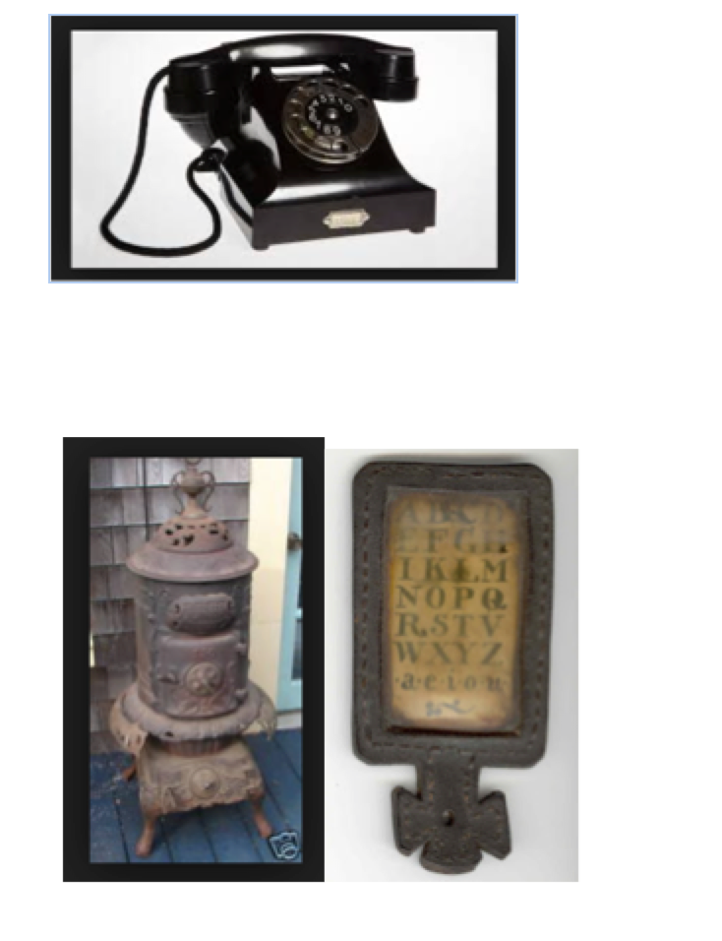
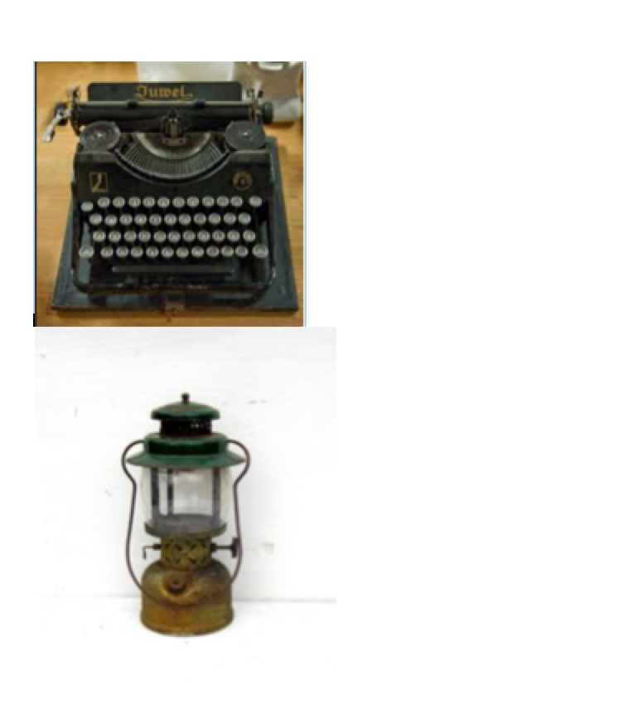

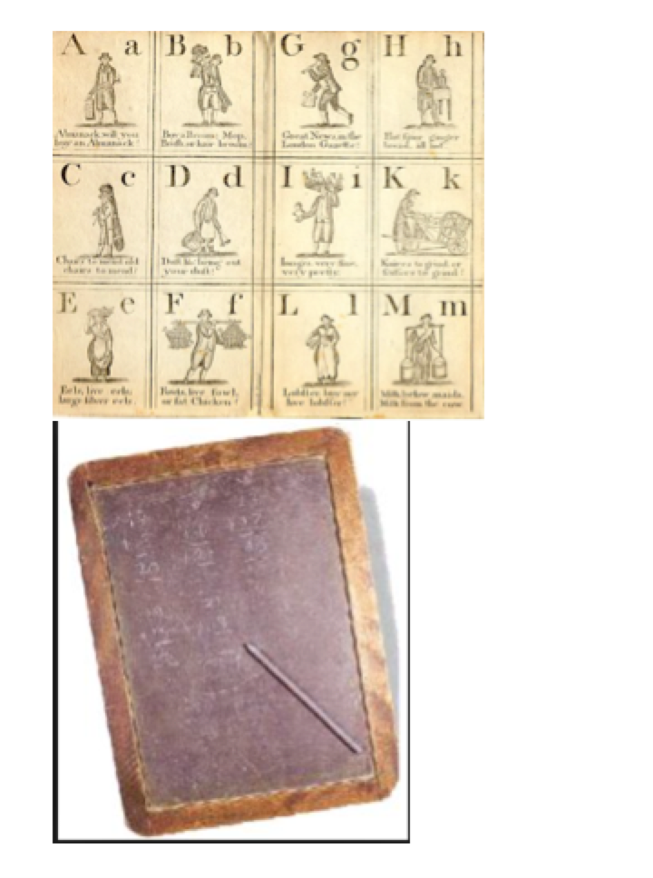

Appendix B

Number the school desks from oldest to newest (1-6).
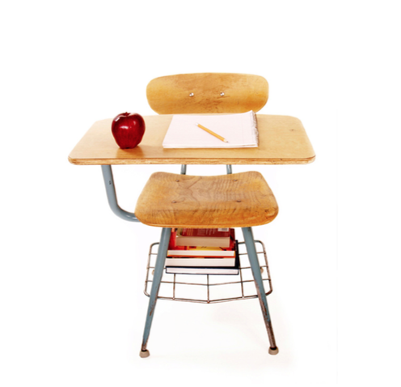
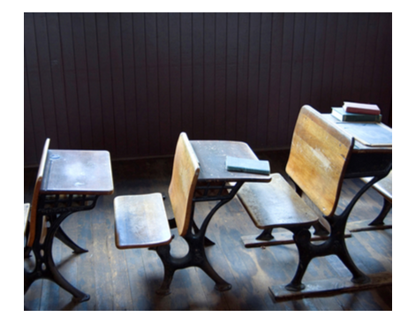
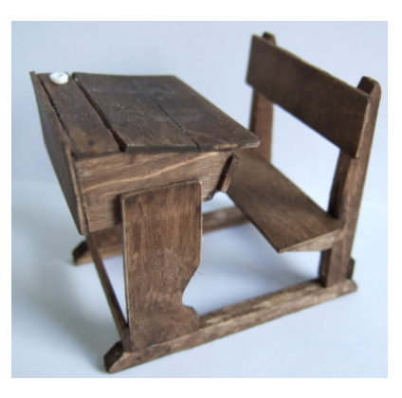
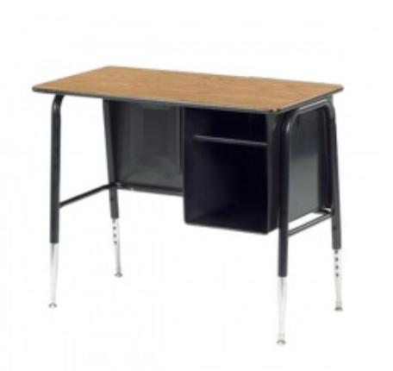
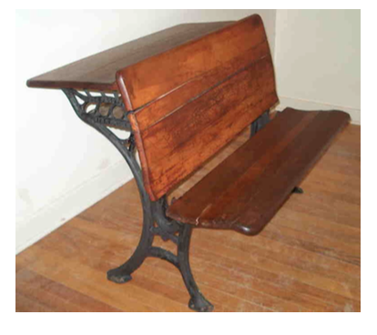
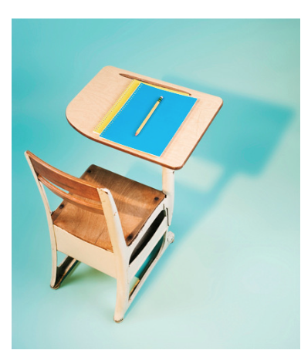

Correct Order from Oldest to Newest (1-6):

1.

2.

3.

4.

5.

6.

Appendix C
Artifact Hunt

Name: ________________________________________________

Artifact #1: ________________________________________

_______________________________________________________________________

_______________________________________________________________________

_______________________________________________________________________

_______________________________________________________________________

Artifact #2: ________________________________________

_______________________________________________________________________

_______________________________________________________________________

_______________________________________________________________________

_______________________________________________________________________

Artifact #3: ________________________________________

_______________________________________________________________________

_______________________________________________________________________

_______________________________________________________________________

_______________________________________________________________________

Artifact #4: ________________________________________

_______________________________________________________________________

_______________________________________________________________________

_______________________________________________________________________

_______________________________________________________________________

Artifact #5: ________________________________________

_______________________________________________________________________

_______________________________________________________________________

_______________________________________________________________________

_______________________________________________________________________

Artifact #6: ________________________________________

_______________________________________________________________________

_______________________________________________________________________

_______________________________________________________________________

_______________________________________________________________________

Appendix D
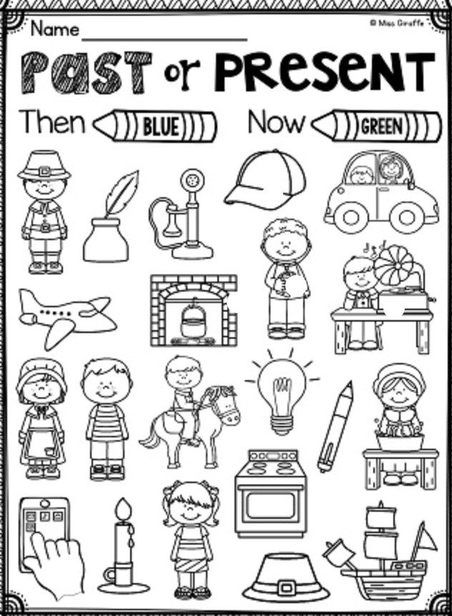

Appendix E

School Long Ago and School Today:
Write 3 items from what school used to have or were like, then to the right, write how it is different today.

School Long Ago | School Today

Appendix F

Artifact Explainations:

Artifact #1 – Telephone: The telephone is different from today’s telephone. We now have wireless phones when in the past, we did not.

Artifact #2 – Coal Stoves: The schools had to use this for heat. In order to keep the fire going, coal or wood had to be placed in the stove.

Artifact #3 – Typewritter: There used to be typewritters instead of computers. Children in schools didn’t use typewriters, but as they got older and went to college, they learned how to type using this.

Artifact #4 – Lantern: Lanterns were used as the source of light within the classroom. They were burned by oil.

Artifact #5 – Slate: This is like a chalkboard. Students would use chalk and practice their math and spelling on these boards.
Artifact #6 – Hornbook: This is a hornbook, which looks like a paddle. A sheet of paper was nailed to the wood. It usually contained the alphabet.

Artifact #7 – Primer: This is a primer. This was used teach the alphabet and other simple words.

