Jackie Meier

EDU 413

12/16/16

Abstract
This paper will focus on creating a strategy for each of the 6 types of parent involvement, which are parenting, communication, learning at home, volunteering, decision-making, and collaborating with the community. I focused my paper on talking about the strategy I would use along with a poster, email, newsletter, and calendar to give to the parents.

Parenting
For parenting, I will provide parents with the opportunity to take classes on parenting/transition periods (entering a child into kindergarten or a child entering elementary school to middle school). This class will be one and a half hours long and focus on handling problems at home, transition stages, improving communication, teaching responsibility and values, how to stimulate independence, and coping with difficult topics such as drugs, divorce, or moving to a new school. These classes will be held the second week and third weekend after school begins. Since it will be held at the beginning of the year, parents will be able to better prepare themselves as their child is entering a new school year.
Before school begins, I will contact the librarian to see if it is okay if she would volunteer during the set class dates/times to provide childcare. If she is unable to attend a day, I will inform the teachers and ask for their help reminding them that this is a great opportunity for parents.
Once school begins, I will inform my other staff members [principal, teacher(s), occupational therapist(s), speech therapist(s), and counselor(s)] about the event that I am doing. I will ask for them to print off the poster and give it to their students to take home and give to their parents (see appendix A). This opportunity is available to all parents with a child in any grade. I will also print off the posters and send it home with my students for them to give it to their parents. I will also email all of the parents about the opportunity and attach the poster. To get the word out about the event, I will not only email the parents, but I will also post a notice in the newspapers and contact the radio about the opportunity.
During the event, I will greet each parent at the door. I will have posters up to lead the parents who brought their child to the library if they are unsure where to go. Greeting the parents at the door will help them feel more comfortable and it will make the class feel welcoming (“How to Start,” n.d). I will also let the parents know as they are walking in about refreshments near the front of the classroom. The seating arrangement will be in a half circle with adult chairs. The speaker (myself) will include a PowerPoint and leave room for questions after each topic. At the very end, parents are welcome to stick around and ask questions. This will be more of a discussion at the end so each parent can talk about strategies they used in the past or issues they don’t know how to resolve.

Communication
I will provide communication by calling each student’s parents individually letting them know how their child is doing in the class. I will do this once a week for two weeks at the start of the year. After the 2nd week, I will call again on the 5th week to let parents know again how they are doing. On the phone, I will make sure to say a positive thing that their child has done for example, if they helped another student or stopped someone from teasing a child I will mention this on the phone. I will also mention what they will be learning or have learned in the week. This will give the parents an idea of what is going on in the classroom.
I will mention right away on the first week when I call the parents that I will be sending a weekly calendar about the school week home with their child and they are supposed to read the information within the calendar if there tends to be any changes about the week (see appendix B). This weekly calendar will be given out at the end of the day on Monday’s for the child to take home. Within the calendar, there will be information about what they will be learning in each subject during the week, what will be served for breakfast and lunch, and other events that their child is in or events for the parent and child to attend.

Learning at Home
There are many opportunities for the parent to educate their child at home. Even without teaching, the parent can take their child to museums, educational movies at the movie theater, or simply walking to a new environment. There are many different website resources a parent can use to help their child succeed in school. One resource I found that is very beneficial for parents would be the Parent Toolkit (Parent Tookit Growth Charts, (n.d). This toolkit gives parents an idea of where their child should be academic, nutrition, social, emotional, and physical development. There are tips under the subjects Math and English Language Arts. This is a great website for parents to use.
Another educational resource would be educational apps. These can include but are not limited to the following: Motion Math: Hungry Fish, v2. I; Factor Samurai; Smart Recorder Lite; Rocket Math Free; Story Kit; Sight Words List; MeeGenius! Kids’ Books (“48 Free Educational Apps”, 2013).
I will inform parents about these websites by giving them a newsletter at the beginning of the year (see appendix C). Written in this newsletter will include educational opportunities within the community along with website resources and apps. Sending out a newsletter once a month about different volunteer opportunities can spark an interest for families to become involved (Olson & Fuller, 2012, p. 118). These newsletters will have a different color of paper but same format. This will allow the parent to easily recognize the paper and not just think it is the same newsletter.

Volunteering
In order to encourage parents to become involved within the community and school, I will give my students a poster for them to give to their parents. The poster will have a short message to encourage members to become volunteers. The poster will also mention volunteer opportunities within the community and school (see appendix D). Community volunteer opportunities through United Way Volunteer Bismarck-Mandan would include home delivery packers, mentoring, tutoring, crisis line, food pantry, Girl Scouts troop leader or assistant leader, and S.A.Y YES! To Tutoring. School volunteer opportunities would include being a chaperone on a field trip, being an instructional assistant, ref at sporting games, be a presenter within a classroom about their career, be an assistant at an art/craft/science, etc. shows (Gutierrez, 2016). The times and dates will be included within this poster to draw further interest if they are free during that day and time. I also included my email within the poster for the parents to email back if they have any additional questions or if they want to set up a day to volunteer within the classroom.

Decision Making
For decision-making, I will ask the principal of the school if there could be a meeting once a month involving parents and at least 2 staff members. This meeting would take place on the most convenient day/time for everyone. I will email my students’ parents at the beginning of the school year to see if they are interested in this opportunity to be a voice within the school (see appendix E). I will also have other teachers inside the school to email their students’ parents also. I will have a list of days and times out of the week on survey monkey for parents to choose what works best for them. I will mention that it will be the second week at the start of each month. After a week from the email being sent, the highest vote will be the set day and time for the meeting, which will be held each month.
After the survey is finished, I will email the parents letting them know about the meeting time and place which, will be held in the teacher’s lounge within the school. There is no limit to the amount of parents that will be attending the meeting. The more parents who are there, the more opinions there will be, which will help the school grow to be more successful.

Collaborating with the Community

To collaborate with the community, the school will host an event open to the public about a famous book author within the area. This event will be held on a Saturday afternoon at 1pm so people are able to attend the event. The book author will speak about his or her book and why she or he loves reading and the importance of it. The author will also read a book that they wrote. If it is a chapter book, the author will read a couple of pages to give an idea of what the book is about. After the presentation, there will be books available for people who would like to purchase and have his signature.
The school will also host other speakers within the area to talk at the school. This may include talks about leadership, our education system, how to raise successful kids, and the good and bad of technology. All of these speeches will be open for the public to hear. This will be organized by the teachers within the school to reach out and find someone that has an interest to speak to the community. In order to increase community participation for the event, there will be an opportunity for those who are interested to speak, to sign up after each event.

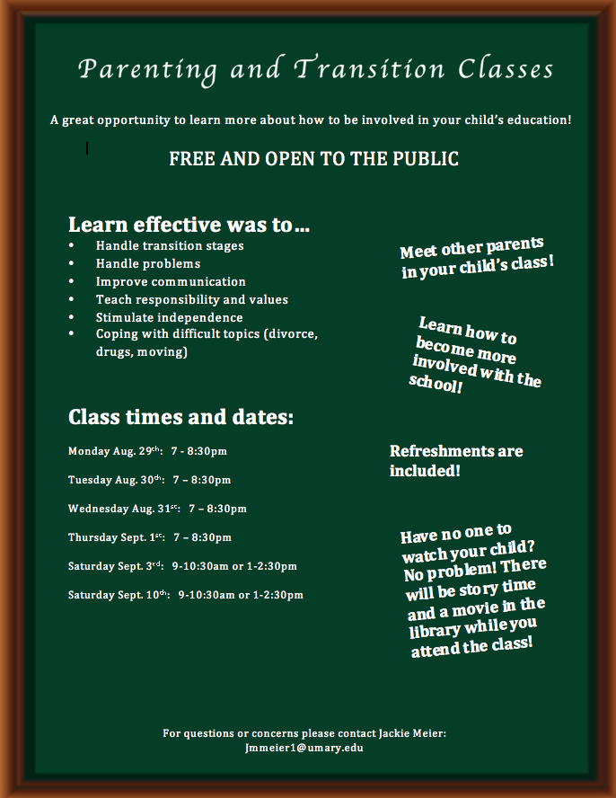
Appendix A
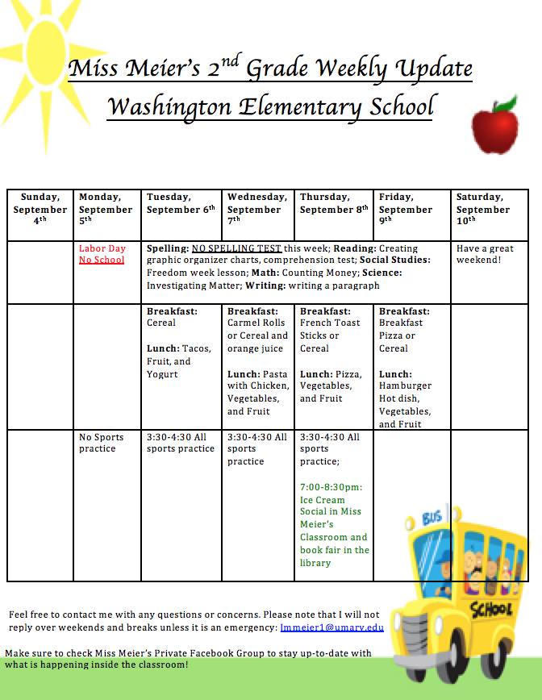
Appendix B
Appendix C

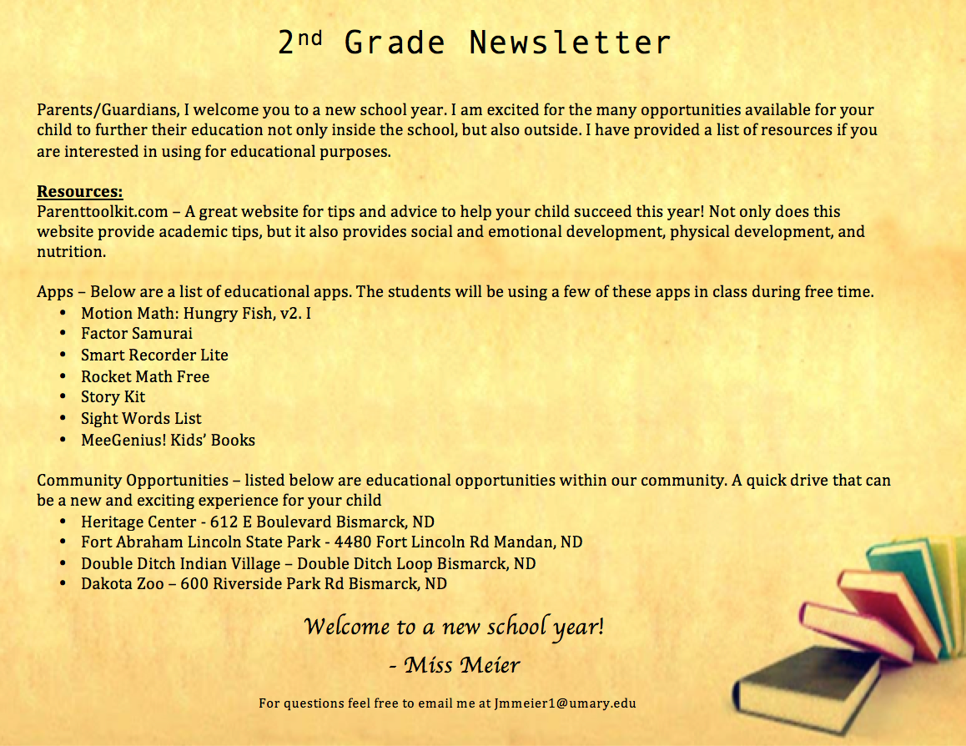

Appendix D
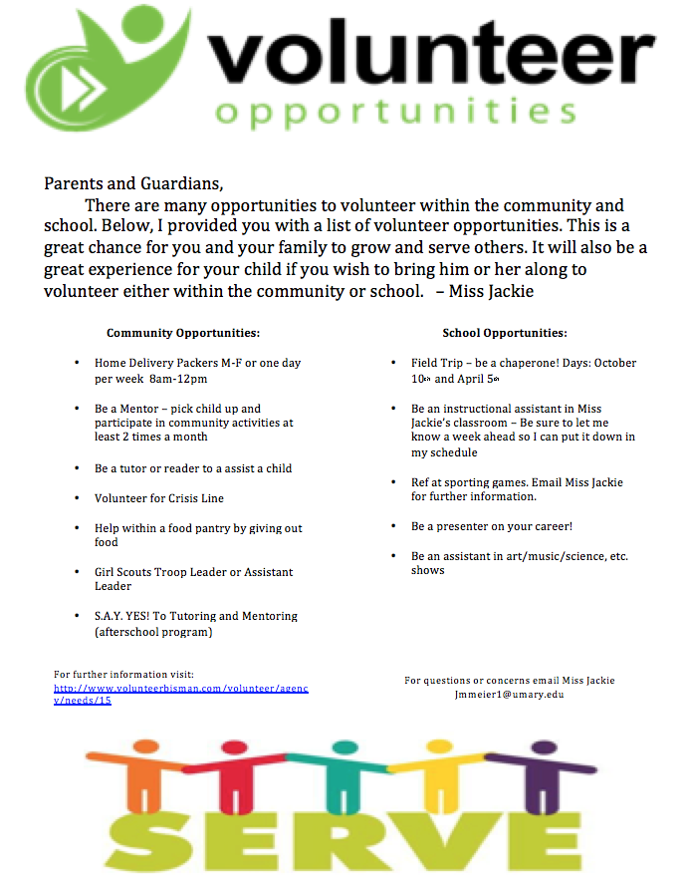

Email Miss Jackie (see below) to set up a day if you would like to volunteer!

Appendix E

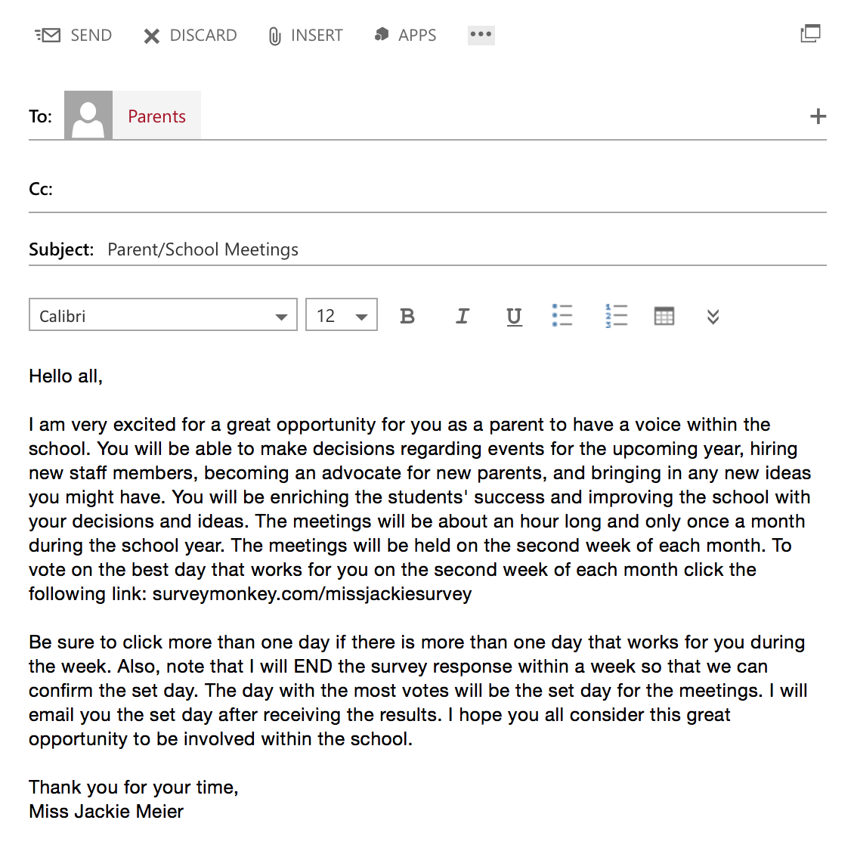

References

Gutierrez, S. (2016). Volunteer Opportunities. Retrieved December 10, 2016, from http://preuss.ucsd.edu/parents-and-families/parent-volunteer-opportunities.html

How to Start and Promote a Parenting Education Group. (n.d.). Retrieved December 6, 2016, from http://www.activeparenting.com/How_to_Start_Guide2

Parent Toolkit Growth Charts. (n.d.). Retrieved December 10, 2016, from http://www.parenttoolkit.com/index.cfm?objectid=71237350-9D75-11E3- 857E0050569A5318

United Way Volunteer Bismarck-Mandan. (n.d.). Retrieved December 9, 2016, from http://www.volunteerbisman.com/

48 Free Educational Apps Rated And Sorted By Grade Level. (2013, March 18). Retrieved December 10, 2016, from http://www.teachthought.com/the-future-of- learning/technology/48-free-educational-apps-rated-and-sorted-by-grade-level/

