Cultural Diversity
Jackie Meier
University of Mary

Diversity is a variety of people from different race, ethnicity, gender, nationality, religion, etc. In this paper, I intend to reexamine my autobiographical paper written at the start of the semester and talk about what diversity means to me personally while also incorporating via the following themes Everything You Wanted to Know about Indians but Were Afraid to Ask; Social Context of U.S. Schooling; Minority Voices; and Promoting Change and Achievement.
For the first theme, Everything You Wanted to Know about Indians but Were Afraid to Ask, I will be addressing the history, culture, powwow, tribal languages, and politics. For the second theme, Social Context of U.S. Schooling, I will be addressing a school climate, and how teaching is a power to influence. For the third theme, Minority Voices, I will be addressing the poor and working-class, LGBTQ issues, and people with disabilities. For the last theme, Promoting Change and Achievement, I will be addressing the achievement gap between minority and dominant-culture students, transforming knowledge, and an advocacy for educators.
From these themes, I will address questions within the book using the knowledge I now have about cultural diversity. Diversity is important not only in a school setting, but it is very important in everyday life. Society today is so focused on becoming more diverse. Workplaces tend to hire someone from a diverse background rather than someone from no diverse background. This could be because of new ideas that they may have for that workplace. Being in a diverse school can help a student prepare for the real world when working with other people from different religions, countries, or ethnicities. The themes I will be addressing will give the reader a better understanding of the challenges others face with diversity but also the advantages they have from becoming more diverse.
Everything You Wanted to Know about Indians but Were Afraid to Ask
Treur (2012, p.18) talks about the history of Native Americans. He explains that Native Americans are not immigrants; they are indigenous to North America. A lot of people may be immigrants in America, but Native Americans are not. I do feel as if people treat Native Americans as immigrants’ more than respectful citizens. I think this has to do with the different way of living, but even this should not be a factor in treating others harshly. Since I was from a small town public school system, my school did not have much diversity. The people within the school tended to be racist towards others from a different ethnicity or religion other than Christian. However, throughout high school, I do think the media played an effect in changing people’s views to be less racist. “Media and social views probably have a greater impact on the perspectives of young native people today than the traditional values around gender roles or homosexuality (p. 18).” Media does play an impact on other people’s views (See Appendix A). With more and more television of homosexuality, teenagers start to think that it is okay.
Since homosexuality is part of today’s culture, it is also part of the Native Americans but of course the views on homosexuality varies. The culture within Native Americans is quite different than White Americans. One particular cultural perspective would be the Indians long hair. The long hair represents spiritual power or strength, which results in a source of pride and self-admiration. Long hair is a symbol in their culture (Treur, 2012, p. 39). When I traveled for the first time to Europe, I didn’t realize how different their culture was from my own. By going and visiting a place entirely different from what I was used to, I was able to learn the most about diversity because I experienced so much more than just visiting with a person.
In order to understand the Native American culture, a person would have to experience a part of their culture different from their own. A great experience could be a powwow. A powwow is a dance event where people wear beadwork, feathers, etc. and dance to songs performed by drum groups (See Appendix B) (Treur, 2012, p. 68). By being a part of the culture, a person will be able to better understand someone from a different background. However, there would be a language barrier when experiencing another culture. When traveling to a different country, I didn’t realize there would be a large language barrier. A lot of people told me before I went to Europe that mostly everyone knew how to speak English. They also mentioned that I shouldn’t worry about not understanding the other language since they would understand English. I found out that this was not the case. Yes, some people did speak English, but a lot of people did not. Just as Native American children do to learn their language, I had to learn a different language by observing and listening to others speaking the language (Spradin, 2012, pg. 91).
As I mentioned that there was a language barrier when I was traveling, it would be because I did not understand their language. Although each country has it’s own language, the tribal language in North America is around 180, but is shrinking dramatically (Treur, 2012, p. 79). I do think that as a student in a North Dakota Elementary school, we should have learned about this language partly because there are many students who are from this background and have this language as their first language. Understanding the different culture at a young age will help the students grow to be diverse and avoid racism. Also, Tribal languages are the first languages to be used on this land by the Americans (p. 79). Incorporating the language within a lesson will solve a language barrier in the classroom especially since many small town schools do not have students that are diverse.
Barriers that we also come across would be that many Indians live in reservations rather than in a community. It is rare to have a Native American as a neighbor within a small town community since many of them stay away and have their own community in a reservation. Reservations are lands retained of the original tribal homeland given to Native Americans (Treur, 2012, p. 87). The United States government took away their land and anything that was left; they decided to make this known as a reservation for the Indians. Although many Indians live on reservations, a lot live off due to unemployment rates being high. Some Indians marry a person from a different race, which brings a lot of Indians living off-reservation (p. 97). If more Indians live-off reservation, the public schools would have an increase in a different culture.
Social Context of U.S. Schooling
Culture plays a role within a school. Educators should respect and understand different cultural perspectives, as there has been an increase of different cultures within schools (Spradin, 2012, p.5). I think it is easier when a child is younger and learns about the different cultures rather than learning about it when they get older. When they are younger, they know that others think differently than they do. When working at an afterschool program (MREC) at Pioneer Elementary School, I make sure to incorporate different cultures within a lesson. By incorporating different cultures within a lesson, students will grow up to know and have a greater understanding about different cultures. Someone who has never been exposed to different cultures will develop culture shock and won’t understand the variety of cultures. By explaining the different cultures, this will not happen.
In order for students to grow up and understand the variety of different cultures, the teacher must incorporate cultures within their lesson or classroom. Bringing in people to speak and interact with the students will help them better understand other people that have a different culture from their own. Also, having a map and pictures on the wall of diversity can increase a child’s understanding (See Appendix C). Teachers must also be aware of what goes on not only inside the classroom, but also on the outside. There are different races within a classroom and teachers must let their students know that they need to respect one another (Spradlin, 2012, p. 7). When I was a student in Elementary school, I thought my teacher was always right and I respected her views and thought that was the way we were supposed to believe. If my teacher were against others from different races, I would have been also. Teachers have the power to influence their students to respect those from a different race or view. I have been able to increase diversity among the students at MREC by opening discussion of the variety of different traditions families do. I haven’t talked about the poor and working class at MREC, but I think this would be a good topic to address within a lesson.
Minority Voices
Spradlin talks about the poor and working-class. He mentions that the poor are hidden from America’s view and the way they are presented is very distorted. The media shows that the poor is undeserving and lack motivation and intelligence (Spradlin, 2012, p. 169). I agree that the media can distort an image of a poor family. The media shows “the perfect life” of a middle class family when this usually is not the case. The media also has increased lesbian-gay-bisexual-transgender-questioning (LGBTQ) actors than ever before.
The media displays LGBTQ on television shows to make it more acceptable among American citizens. This subculture became visible in the United States around the 1920s and 1930s (Spradlin, 2012, p. 209). From High School, we had a diverse student who was African American in our class. She had different beliefs than all of us. She would speak up about pro-choice or how she accepts same sex marriage. I was not a fan of her always bringing it up but now as I look back, I am glad that she did. My classmates and I were never challenged with our beliefs. She opened our eyes to see that there are other people who are different than us. She helped me understand that even though I may not agree with someone’s actions, they are still human and I must not judge them cause only God is the one to judge. LGBTQ citizens still continue to struggle against discrimination and negative stereotyping in the wider society (p. 212). However, I do think it is becoming more accepted depending on the location a person is at. For example, I grew up in a very republican small town high school where people would frown upon a person being gay. If I had gone to a high school in New York, people would be more acceptable towards others that are gay in the school. I think it depends on the location and views within a community.
People with disabilities used to not have equal access to learning (see appendix D). Today, that has changed and now students are able to have the right to receive education no matter their disability. “Teachers must take responsibility for creating environments in which students at all levels achieve (Spradlin, 2012, p. 238).” What I have learned from previous special education classes is that many teachers do not focus on meeting goals for students with disabilities. They know that the student will have a tough time but do not work with them to meet a specific goal that they are capable of reaching. I think teachers need to realize this and be aware that student’s with disabilities are capable of accomplishing set goals. At MREC, there is a young girl who has Down syndrome. The teachers at this school do not baby her because of her disability; they push her to succeed because they know she is able to do so. As a teacher, I will be aware of their weaknesses and strengths and develop a plan to help them reach a goal that they will be able to achieve.
There are many things that I can do to help a person with a disability to reach a goal. Today, with the technology now available, it makes it easier to communicate with a person that is unable to speak (Spradlin, 2012, p. 248). For teachers, using technology to help the children with a disability that is unable to speak enhances the child’s ability to learn and communicate with the teachers (See Appendix E). For example, there is an app that has words for a person to push and that word will be said aloud for those around to hear. Having this technology is a huge benefit in a classroom because a teacher will know if the student is able to understand the material or not.
Promoting Change and Achievement
There is an achievement gap between minority and dominant-culture students. “The theory assumes that the fundamental educational practices and skills that White middle-class children learn are not represented and taught in minority student homes and thus disadvantage children from these communities in schools (Spradlin, 2012, p. 265). My parents did not talk about the wide variety of different cultures and people that I will encounter with later on in life. My dad gave the impression of racism, but my mom always would disagree with him and say he is not supposed to be this way. Since my mom wasn’t racist, I knew that being racist was not a good thing. Some parents may give the impression of racism and it can greatly make the child think this way also. I do think that by teaching children at a young age about different cultures will close the gap of cultural deprivation.
When teaching students at a young age, teachers must know about the hidden “truths” within education (Spradlin, 2012, p. 286). Many textbooks distort the truth and focus on dominant culture perspectives and interests (p. 295). As a teacher, I will carefully look over the curriculum and seek the hidden truth. Transforming the curriculum can be a challenge as marginalized groups are devalued in their curricula. By understanding this I will be able to teach about awareness of race gender, social class, and sexual orientation are all part of today’s world (p. 295). Students will come to realize that it is okay to be of a different race or social class. We are all human no matter if we have a different background.
As a teacher, by becoming an advocate and agent for change in schools will benefit the school to becoming more diverse and open towards others. As a teacher, I cannot be just aware about the issues concerning minority students, I need to be active and help with the students’ academic achievement (Spradlin, 2012, p. 299). In order to change students to start thinking diversely, I will need to confront the forces affecting their achievement. By creating an environment within the classroom where students can come to trust one another and are encouraged to express their opinions and feelings, I will know that I have accomplished my job as a teacher for my students to be diverse (p. 305). Open discussion is important within a classroom because it gets the students to think of other’s ways of thinking and to challenge one another to think deeper. I will incorporate open discussion within my classroom to bring more communication and trust between my students.
Conclusion
In light of all the themes I have discussed and incorporated into my autobiography, I will address a few questions along with my own opinion supported by the text. Questions I will address will include: How will Native Americans play a part in my career? How will I incorporate students to learn different cultures within the classroom? How does the media distort the poor and working class? How can I as a teacher address the LGBTQ issue without drawing offense? How will I address students with disabilities in a classroom and overcome challenges to help their educational needs? How will I as a professional, solve the barrier between races? And, how can I be an advocate for change in schools?
How will Native Americans play a part in my career?
Since I will be teaching for a couple of years in North Dakota, I will experience having Native Americans as my students within the elementary schools. I do think I have a greater understanding of their culture from this class. I understand that they have different values and traditions I need to be aware of. I have to draw the barrier and incorporate some of their values and traditions within a lesson. This will help build trust between a Native American student and myself as a teacher. Along with the language barrier, incorporating a lesson on the language can also draw the barrier between communicating with the student.
How will I incorporate students to learn different cultures within the classroom?
I will incorporate different cultures within the classroom by beginning a lesson about the place and the way people live. I will then bring in some traditions they have such as certain clothing they may wear, music they listen to, or food that is different from my students own. This will help my students better understand of clothing, music, and food that is out there which is different from their own. I will then bring in a speaker that will talk about the traditions and culture to help my students fully understand that there is a person from this culture. Allowing the speaker to interact with the students will give them a greater sense of diversity. This will also promote the students to interact with students that are from a different culture of race. As a teacher, I have the ability to influence my students to respect others (Spradin, 2012, p. 310).
How does the media distort the poor and working class?
I do think the media distorts the image of a poor and working class. They show that the poor isn’t intelligent, which is not always the case. They just do not have the opportunities to further their knowledge hence college education (Spradlin, 2012, p.169). As a teacher, I will be aware of this for students that are among the poor class in my classroom. I will make sure that they know they are capable of doing whatever they want to do with their life as long as they are determined and are willing to work hard to get there. By proving that they are capable of being successful, I will mention leaders such as Howard Schultz, Oprah Winfrey, and Ralph Lauren. This will help them understand that they are capable of making their dream a reality.
How can I as a teacher address the LGBTQ issue without drawing offense?
I do think this is a touchy topic to talk about with students. Since I am going to teach the younger elementary students hopefully first or second grader, I don’t think I will come into encounter with these issues among my students. However, they could come from parents that are lesbian or gay. Then, I will have to be careful and let my students know that there are couples that are of the same sex. I do not foresee this becoming an issue at a young age. If I do teach 3rd, 4th, or 5th graders, they could potentially be either LGBTQ since it is well known today. As a professional, I will be aware so that I am able to respond and create a safe learning environment (Spradlin, 2012, p. 227). By being aware, I won’t be in denial and unprepared if this were to occur within my classroom.
How can I incorporate a lesson to teach my students to not be discriminating against others from a different race?
Since I will be teaching elementary aged children, they will start to be explained about the history of slavery. To help them understand what exactly segregation looked like and feels like, I will do a lesson to separate the blue-eyed children from the brown-eyed children (See Appendix F). Just like in our presentation, the blue-eyed children will be able to get privileges but the brown-eyed children won’t. Of course myself as the teacher will have to let them know that this is pretend and I am not actually segregating them personally. I am showing them what it was like. This activity will enable the students to experience what segregation was like within a classroom.
How will I address students with disabilities in a classroom and overcome challenges to help their educational needs?
I do think that children with disabilities should stay in the general education classroom because they not only can learn from the teacher, but also from their peers. In the past, people with disabilities were taught in a separate classroom and they have been victims of discrimination and cruelty (Spradlin, 2012, p. 238). When a student who has a disability within a classroom is being bullied, I will need to address this issue and stop it now or else it could continue throughout the child’s educational career. I will teach all of my students to be accepting towards others that may have a disability. I will talk about famous Olympic swimmers or gymnasts that have accomplished winning a gold medal even though they have a disability. Everyone deserves equal education within a school and I will help students with disabilities to achieve a set goal of theirs.
How will I as a professional, solve the barrier between races?
Yes, people may be of a different race but there is one race on the Earth, which is the human race. As humans, people have separated one another into races to feel more grander to others (Spradlin, 2012, p.7). As an educator, I will lead people out of ignorance of thinking they are better than someone else. Teaching children at a young age about the variety of cultures will close a gap of cultural deprivation.
How can I be an advocate for change in schools?
As a teacher, by becoming an advocate and agent for change in schools will benefit the school to becoming more diverse and open towards others. As a teacher, I cannot be just aware about the issues concerning minority students, I need to be active and help with the students’ academic achievement (Spradlin, 2012, p. 299). In order to change students to start thinking diversely, I will need to confront the forces affecting their achievement. By creating an environment within the classroom where students can come to trust one another and are encouraged to express their opinions and feelings, I will know that I have accomplished my job as a teacher for my students to be diverse (p. 305). Open discussion is important within a classroom because it gets the students to think of other’s ways of thinking and to challenge one another to think deeper. I will incorporate open discussion within my classroom to bring more communication and trust between my students. This will allow the student and I to work together in order to achieve their academic goals.
In light of everything I have learned from this course, I will further my education learning about others from different cultures by going out and experience their culture. I will for example, spend time volunteering at the United Tribes Technical College to interact with the students and see their culture through experience. I will educate my students through interaction of those from a variety of different cultural backgrounds whether this may be bringing in a speaker, food, or videos. I will go beyond the classroom and incorporate a speaker for families to come in and listen to. This will help not only the students learn more about others from a different background, but also the parents to become more culturally diverse.

Appendix A

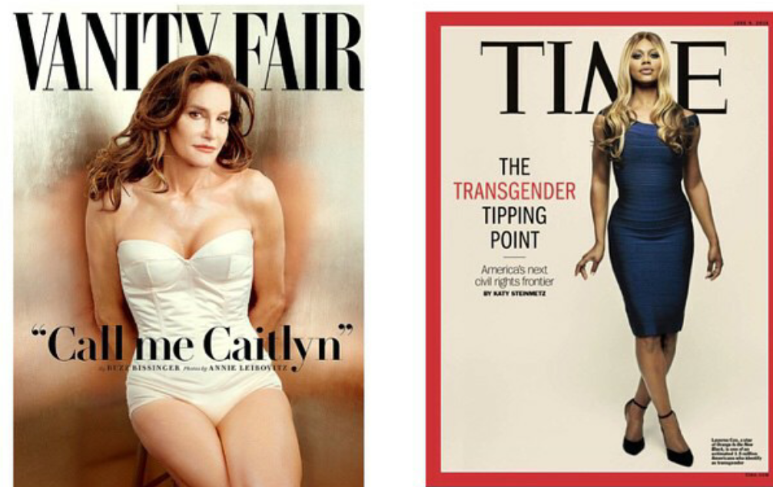

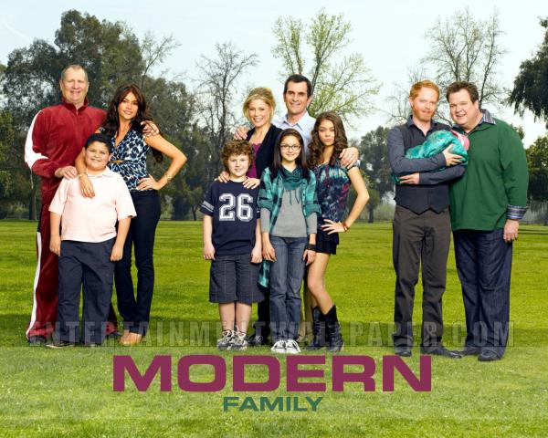

Visit the following website to view news articles on television shows involving LGBT characters: http://www.huffingtonpost.com/news/lgbt-tv-shows/
View the following website to see a list of television shows along with the actor/character and their orientation in the show: http://www.glaad.org/publications/whereweareontv11/characters

Appendix B
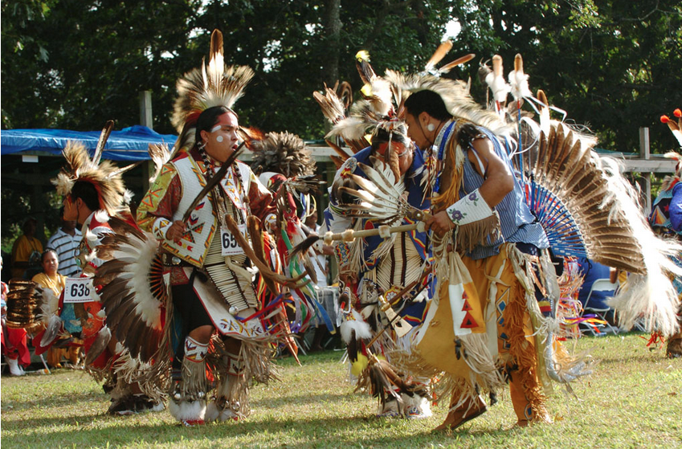

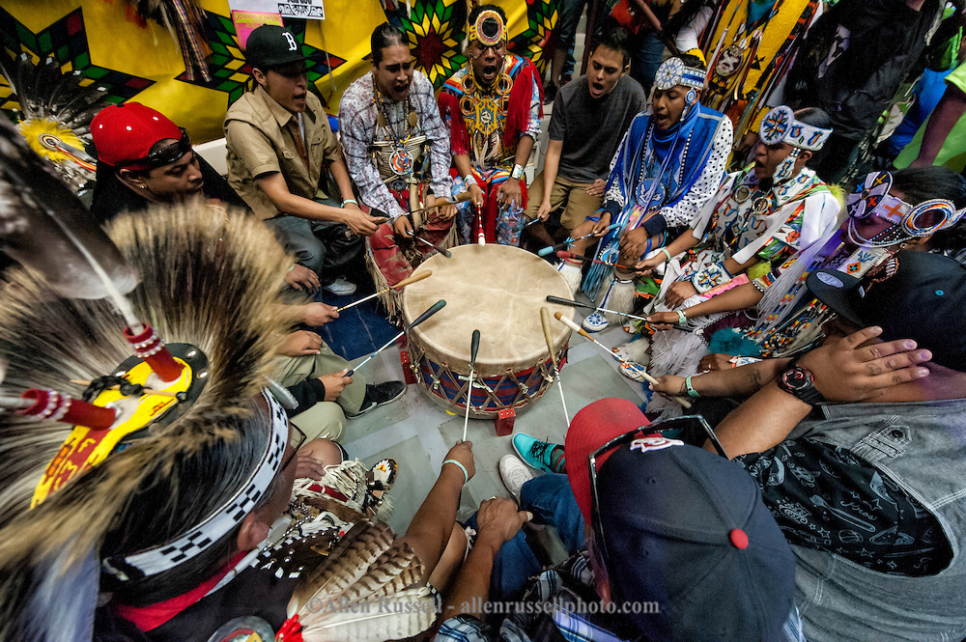
For further explanation on what a powwow is and music/videos/photos, please visit http://www.powwows.com/what-is-a-pow-wow/

Appendix C

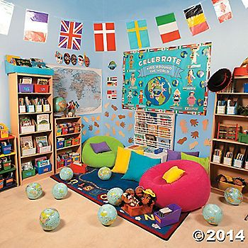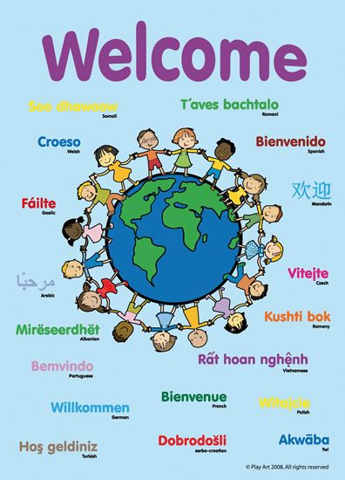

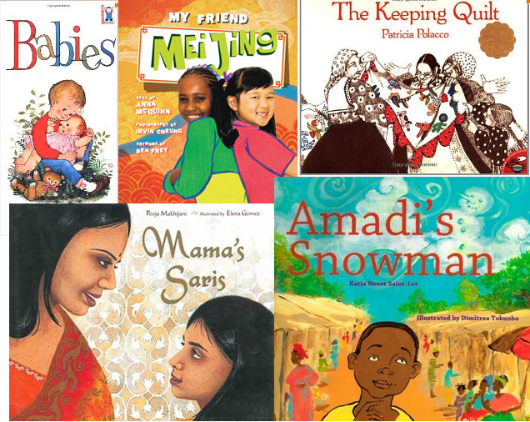
For a list of Multicultural books, please visit:

https://ccbc.education.wisc.edu/books/detailListBooks.asp?idBookLists=42

Appendix D

Categories of Disabilities:
1. Intellectual Disabilities
2. Deaf-Blindness
3. Learning Disability
4. Emotional Disturbance
5. Autism
6. Developmental Delay
7. Speech or language Disorder
8. Traumatic Brain Injury
9. Hearing Impairment
10. Multiple Disabilities
11. Orthopedic Impairment
12. Other Health Impaired (OHI)
13. Visual Impairment

3 Federal laws protect individuals with disabilities:
1. Individuals with Disabilities Education Act (IDEA)
2. Americans with Disabilities Act (ADA)
3. Section 504 of the Rehabilitation Act

To find out what these laws do please visit: https://www.understood.org/en/school-learning/your-childs-rights/basics-about-childs-rights/at-a-glance-which-laws-do-what

Appendix E

List of assistive technology:

- Abbreviation expanders
- Alternative Keyboards
- Audio books and publications
- Electronic math work sheets
- Freeform database software
- Graphic organizers and outlining
- Information/data managers
- Optical character recognition
- Personal FM listening systems
- Portable word processors
- Proofreading programs
- Speech-recognition programs
- Speech Synthesizers/screen readers
- Talking Calculators
- Talking spell checks and electronic dictionaries
- Variable-speed tape recorders
- Word-prediction programs

For further information on each program/system visit: http://www.readingrockets.org/article/assistive-technology-kids-learning-disabilities-overview

Appendix F

Click the following link for the lesson plan on Blue Eye/Brown Eye Activity on segregation.

http://the-classroom.org.uk/wp-content/uploads/2014/07/Blue-eye-Brown-eye-activity2.pdf

References
Spradlin, L.K. (2012). Diversity matters: understanding diversity in schools. Belmont, CA: Wadsworth.

Treuer, A. (2012). Everything you wanted to know about Indians but were afraid to ask. Saint Paul, MN: Borealis Books.

