Classroom Management Plan

Jacqueline Meier

University of Mary

Classroom Management Plan

My classroom management philosophy focuses on being committed to helping my students inside and outside of the classroom. I will provide a safe, welcoming, organized, and structured classroom where positive relationships are built. I find it important for students to collaborate with one another and become respectful individuals.
I would like to teach middle to upper elementary. For the first week, I will be focusing on the procedures and routines. In order to make this engaging instead of just explaining the rules and procedures, I will have the students create a video on the procedure. I will explain to the students the right way to do the procedure, then the students will form groups and explain in the video a correct and incorrect way to do that procedure. This will allow for students to be engaged and also learn how to do the procedure. They will also let the students know what I expect from them.
For the bathroom and morning procedure, I will have a magnetic board and large laminated pictures of the schoolhouse, bathroom, and a house. The students will have a nametag (star) on a magnetic (See Appendix A). I will explain to the students that they must move their nametag (star) to the schoolhouse when they come into the classroom in the morning. This will allow me to quickly see who is absent and who is present for the morning. After they have done this, they will sit down in their desks and look on the board and complete the morning journal entry.
I will also explain that if they need to use the bathroom, they can move their nametag to the bathroom picture. Above the bathroom picture, I will have a little strip of paper that says “Reminder, only 2 students out at a time.” This will just remind students that if they see that there are 2 magnetics on the board, they will be unable to leave the classroom. However, if it is an emergency, they will know that they need to inform me, and then they can leave.
After the students enter the classroom in the morning and move their magnetics to the schoolhouse picture, the agenda will be posted on the smart board (See Appendix B). According to Wong (2014), an agenda posted at the beginning of the day will allow for students to know what will be occurring that day and help students stay focused and on task. I will eliminate many problems such as students wandering around the classroom not knowing what to do, students asking the “What are we doing today?” question, and students transitioning poorly between activities.
In order to build positive relationships within the classroom, I need to get to know my students right away at the start of the first week of school. On the first day, I will have my students fill out a worksheet that will allow me to get to know all about them along with their likes and dislikes (See Appendix C). I need to start building a classroom community. I can do this by getting my students up and moving and talking to one another. I will use a scavenger hunt tool where the students will go around trying to find other students who meet the criteria (See Appendix D). The students that fit the criteria will sign their name in the box. The teacher will allow enough time for students to complete the scavenger hunt. The next day of school, I will ask the questions on the scavenger hunt to see if the students remember who did or likes what. This will start a sense of community within the classroom because the students will be talking with one another and seeing what similar interests they might have.
Another way I will start community within my classroom will be by allowing group discussions. I can do this by creating pods with their desks (See Appendix E). By creating pods instead of rows, the students will be able to feel more involved within the classroom and able to communicate easier with one another. I will also assign roles for each student within each pod. The roles will include leader, errand monitor, presenter, and timekeeper. The timekeeper will also have the role as the recorder. The leader will make sure everyone is speaking and discussing the information. The errand monitor will be the one to get the supplies if there is a group project or talk to other group errand monitors to see what their group is doing. The presenter will present the group’s finished work or let the class know what they worked on during the time period. The time keeper will keep track of how much time they have and encourages the group to continue working. Since the timekeeper also has the role as the recorder, he or she will write down the groups’ ideas and also on the board what he or she wrote.
The teacher will make copies of the roles and hand them out to each group (See Appendix F). The roles will switch each week within the group. This will give the students the ability to speak up during their role. By switching roles each week, the students will know that I respect each one and want the classroom to be a safe and fair environment.
The roles will help the students become responsible however, there needs to be rules and expectations within the classroom. Expectations I will have for my students will include for the students to follow directions, use kind words, be respectful, be safe, raise hand to speak, keep your hands to self, and do your best. The poster will be on the classroom wall during the entire school year for students to see. This will help them know what I expect of them. See appendix G for the poster I will use for my classroom.
I will also have norms posted within my classroom. I will create a list of classroom norms. The norms will be tapped on the wall and the students will get a copy (See Appendix H). I will remind them that these norms are not rules, but things that will make their learning successful. This will also help the students grow individually by allowing them to know and understand what the norms are in society.
In order for my students to grow by becoming more responsible, I will also have a pink slip for students who did not submit their homework on time (See Appendix I). This will prepare students for middle school and also help them take ownership and be aware of the responsibility they need to have. The pink slip will eliminate students from coming up to tell me that they do not have their homework. They will know that if they do not have their homework, they have to fill out the pink slip.
Since students have to get their pink slip signed by a parent or guardian, communication with them is essential as a teacher. I will provide communication by calling each student’s parents individually letting them know how their child is doing in the class. I will do this once a week for two weeks at the start of the year. After the 2nd week, I will call again on the 5th week to let parents know again how their child is doing. On the phone, I will make sure to say a positive thing that their child has done. For example, if they helped another student or stopped someone from teasing a child, I will mention this on the phone. I will also mention what they will be learning or have learned in the week. This will give the parents an idea on what will be occurring in the classroom.
I will mention right away on the first week when I call the parents that I will be sending a weekly calendar about the school week home with their child and they are supposed to read the information within the calendar if there tends to be any changes about the week (See Appendix J). This weekly calendar will be given out at the end of the day on Monday’s for the child to take home. Within the calendar, there will be information about what they will be learning in each subject during the week, what will be served for breakfast and lunch, and other events that their child is in or events for the parent and child to attend.
I will also give opportunities for the parent to educate their child at home. Even without teaching, the parent can take their child to museums, educational movies at the movie theater, or simply walk to a new environment. There are many different website resources a parent can use to help their child succeed in school. One resource I found that is very beneficial for parents would be the Parent Toolkit (Parent Tookit Growth Charts, (n.d). This toolkit gives parents an idea of where their child should be academic, nutrition, social, emotional, and physical development. In order to successfully teach all of my students, I need to make sure the students are getting enough sleep and rest at night so they are focused during school.
I will inform parents about these websites by giving them a newsletter at the beginning of the year (See Appendix K). Written in this newsletter will include educational opportunities within the community along with website resources and apps. Sending out a newsletter once a month about different volunteer opportunities can spark an interest for families to become involved (Olson & Fuller, 2012, p. 118). These newsletters will have a different color of paper but same format. This will allow the parent to easily recognize the paper and not just think it is the same newsletter.
I think it is essential for parents to know that they can get involved with the class. In order to encourage parents to become involved within the community and school, I will give my students a poster for them to give to their parents. The poster will have a short message to encourage members to become volunteers. The poster will also mention volunteer opportunities within the community and school (See Appendix L). Community volunteer opportunities through United Way Volunteer Bismarck-Mandan would include home delivery packers, mentoring, tutoring, crisis line, food pantry, Girl Scouts troop leader or assistant leader, and S.A.Y YES! To Tutoring. School volunteer opportunities would include being a chaperone on a field trip, being an instructional assistant, ref at sporting games, be a presenter within a classroom about their career, be an assistant at an art/craft/science, etc. shows (Gutierrez, 2016). The times and dates will be included within this poster to draw further interest if they are free during that day and time. I also included my email within the poster for the parents to email back if they have any additional questions or if they want to set up a day to volunteer within the classroom.
Building relationships is something I will strive for within my classroom. Once I am able to build relationships, the procedures and expectations I have for my students will prosper. Parent communication is essential and will allow me to learn more the students’ needs and home environment. By providing a safe and welcoming environment where students are respectful of one another and come to trust me as a teacher, I will be able to manage my classroom successfully.

Appendix A

I will use the following pictures, laminate them, and tape it on the side of the marker board.

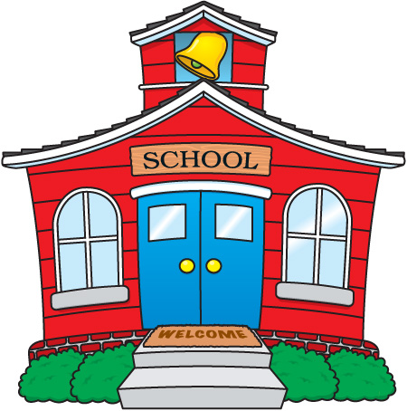

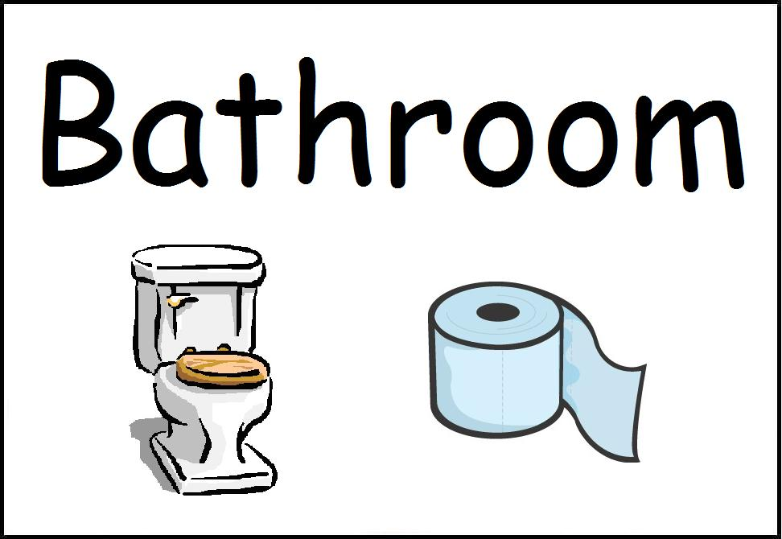

Name Tags:

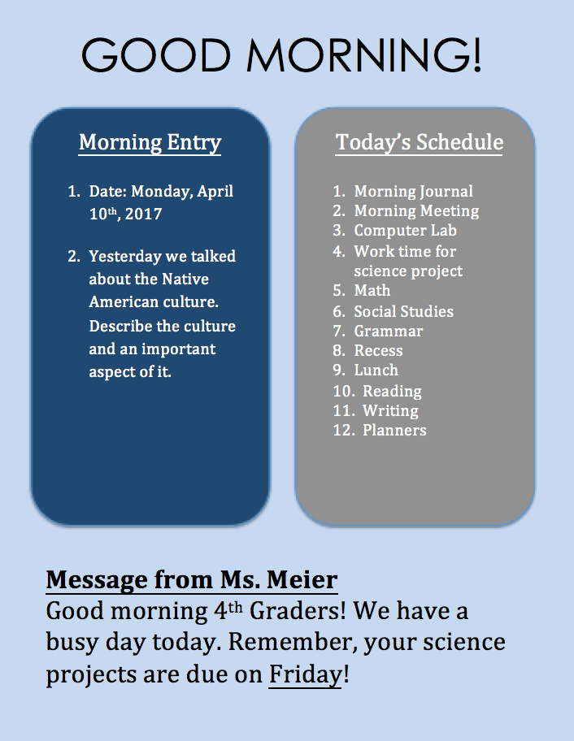Appendix B
Appendix C
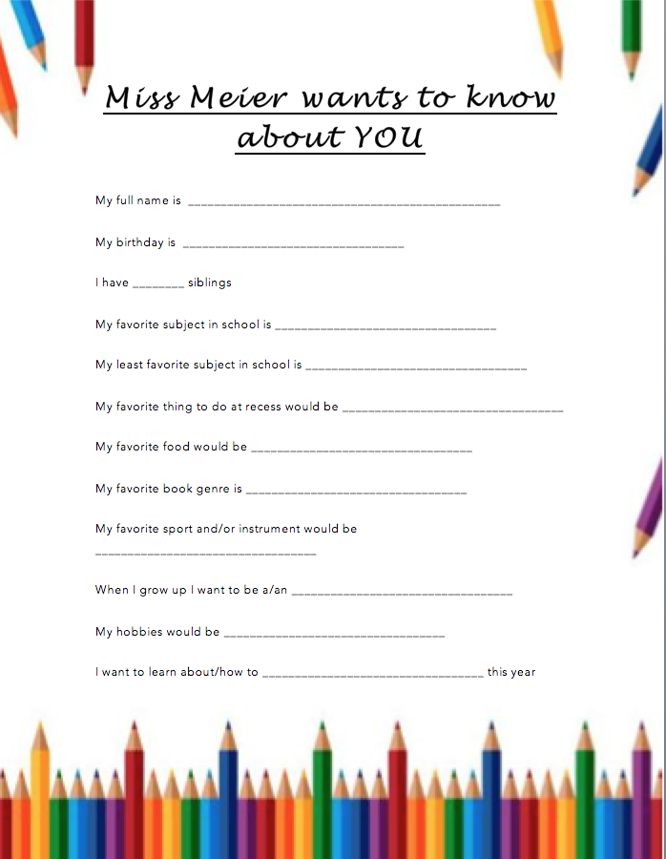

Appendix D
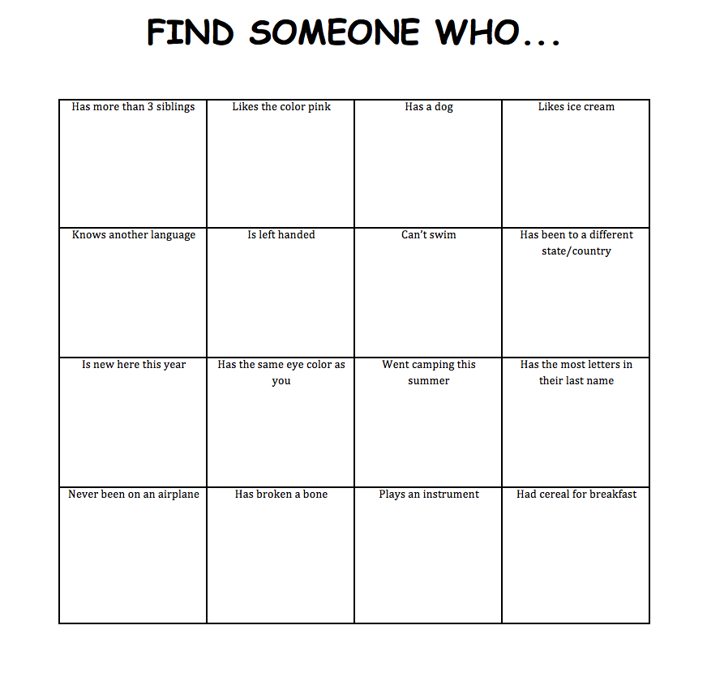
Appendix E
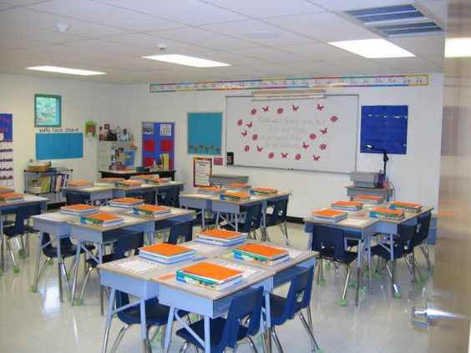
Appendix F

Leader  The leader will make sure everyone is speaking and discussing the information  Ex. “____, you haven’t spoke in awhile, what do you think?” or “Let’s hear from _____ about what he/she thinks.” | Presenter  The presenter will present the group’s finished work or let the class know what they worked on during the time period.
Timekeeper and Recorder  The time keeper will keep track of how much time they have and encourages the group to continue working. Since the timekeeper also has the role as the recorder, he or she will write down the groups’ ideas and also on the board what he or she wrote. | Errand Monitor  The errand monitor will be the one to get the supplies if there is a group project or talk to other group errand monitors to see what their group is doing.

Appendix G

CLASS EXPECTATIONS:

Follow Directions
Use KiNd words
Be respectful
Be Safe
Raise your hand to speak
keep your hands and feet to self
do your best
Appendix H

Classroom Norms:
What is a norm? A norm is usual, typical, the way it is supposed to be.
Within the classroom, there are norms. These norms are for you to respect and understand.

1. Celebrate each other’s success.
2. Disagree with ideas, not people.
3. Take turns.
4. Confusion is part of learning; speak up if you are confused!
5. Learn from your mistakes. We all make them – learning from them is the key!
6. Clean up after yourself always.
7. Tell the truth.
8. Be patient
9. Be kind
10. If you see someone alone, ask if you can join him or her.

Appendix I

Date: ___________________ Name: ____________________________________________

You’ve been Pink-Slipped!
Completing your homework or assignment is your responsibility. Please complete the slip along with your parent/guardian’s signature and return within one day.

Missing Assignment: ______________________________________________________

I do not have my homework today because: (please check one below)

________ I did the assigned homework, but forgot to bring it.
________ I chose not to do my homework assignment
________ I forgot to do my homework assignment
________ Other – Please explain below

Other: ____________________________________________________________________________________________

Student’s Signature: __________________________________________

Parent/Guardian’s Signature: ____________________________________________

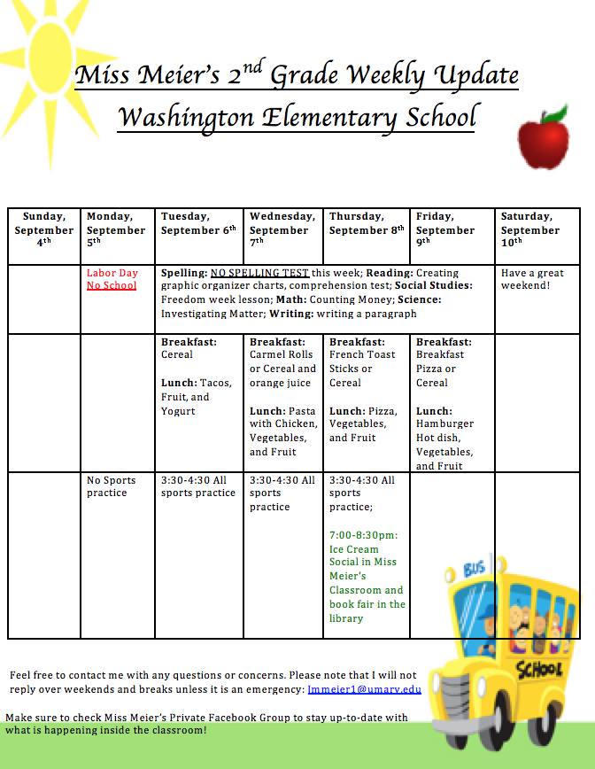Appendix J

Appendix K

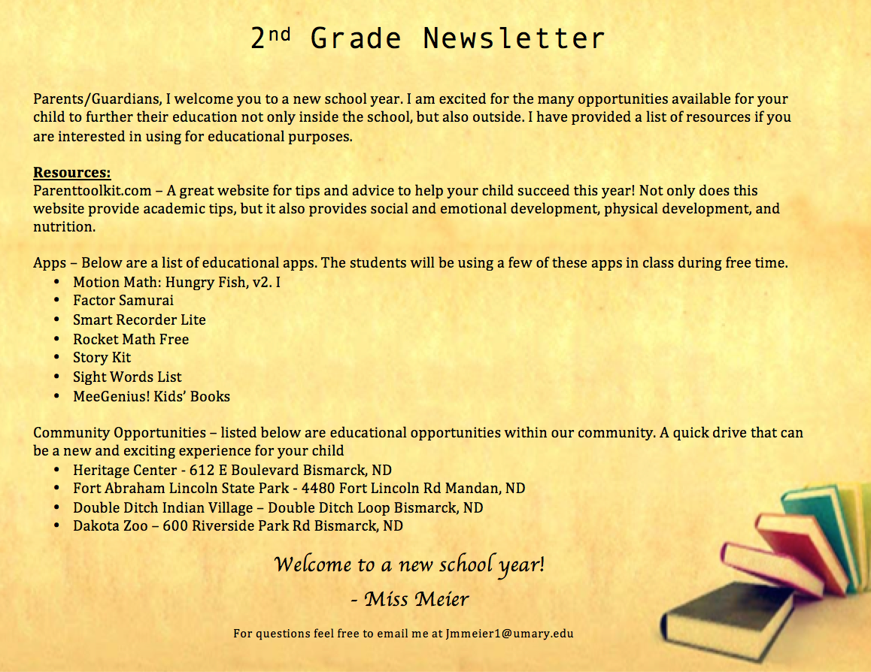

Appendix L
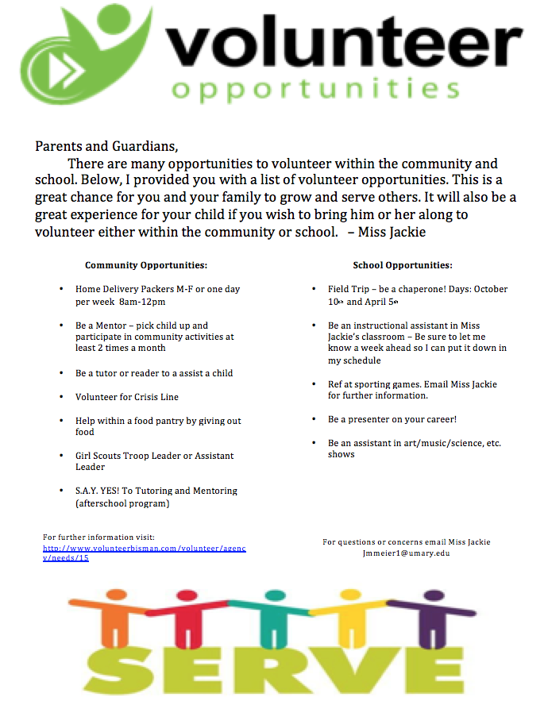
References

Gutierrez, S. (2016). Volunteer Opportunities. Retrieved April 10th, 2016, from http://preuss.ucsd.edu/parents-and-families/parent-volunteer-opportunities.html

Olsen, G. & Fuller, M. L. (2011). Home and school relations: Teachers and parents working together. Boston, MA: Preston Hall.

Parent Toolkit Growth Charts. (n.d.). Retrieved April 10th, 2016, from http://www.parenttoolkit.com/index.cfm?objectid=71237350-9D75-11E3- 857E0050569A5318

Wong, K. H. (2014). The Classroom Management Book. Mountains View, Ca.: Harry K. Wong Publications, INC.

